Hi Friend!

If you are reading this, you have received an invitation to the top procurement analytics event of the year, SievoFriends. We’re back this year with the most requested theme ever: Insights to Action with GenAI. Plus, you will experience Helsinki during summer. An event that combines business and pleasure, sounds perfect right?

There is just one thing. How will you justify this to your boss…? Easy!

Below is a letter template you can use to help justify your attendance to the event in Helsinki. This will outline the value of attending SievoFriends.
You are free to use this template, and customize any elements as needed.
See you in May!
Sievo team

Request to Attend SievoFriends Helsinki 2024

Dear (Your Manager),

The SievoFriends Helsinki 2024 event takes place on May 28th-29th. For several years now, it has been the definitive educational and inspirational event for peers within the procurement analytics ecosystem.
By attending, I aim to enhance my expertise by engaging directly with procurement experts, staying updated on emerging trends such as GenAI and ESG, and expanding my professional network.
Hence, I would like to request your approval to attend the event.
Below is the current agenda for the Helsinki event, with more sessions and speakers expected to be announced.
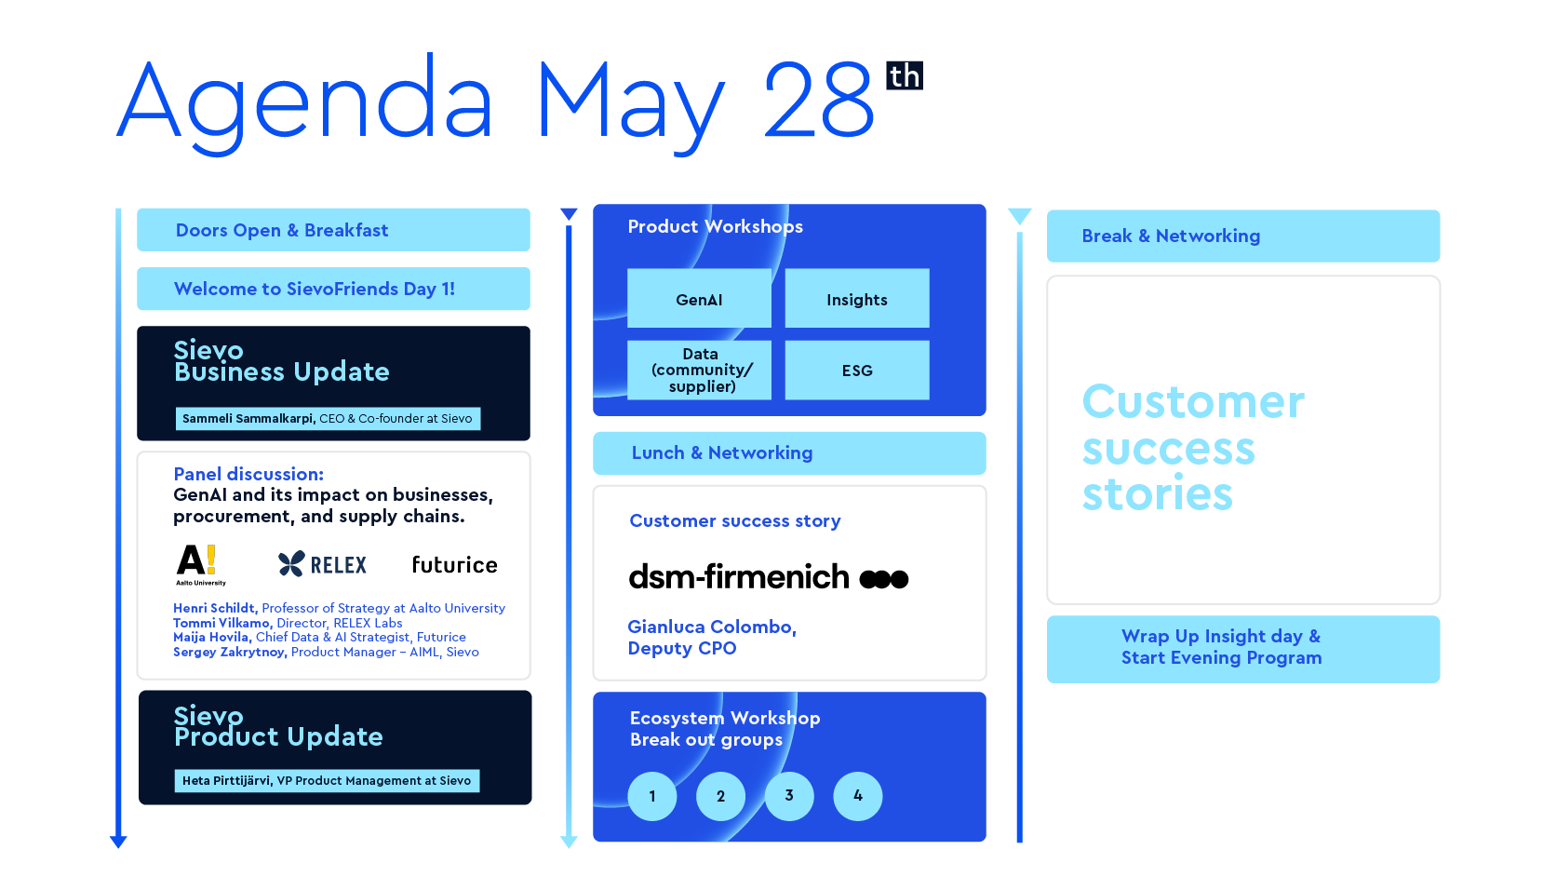
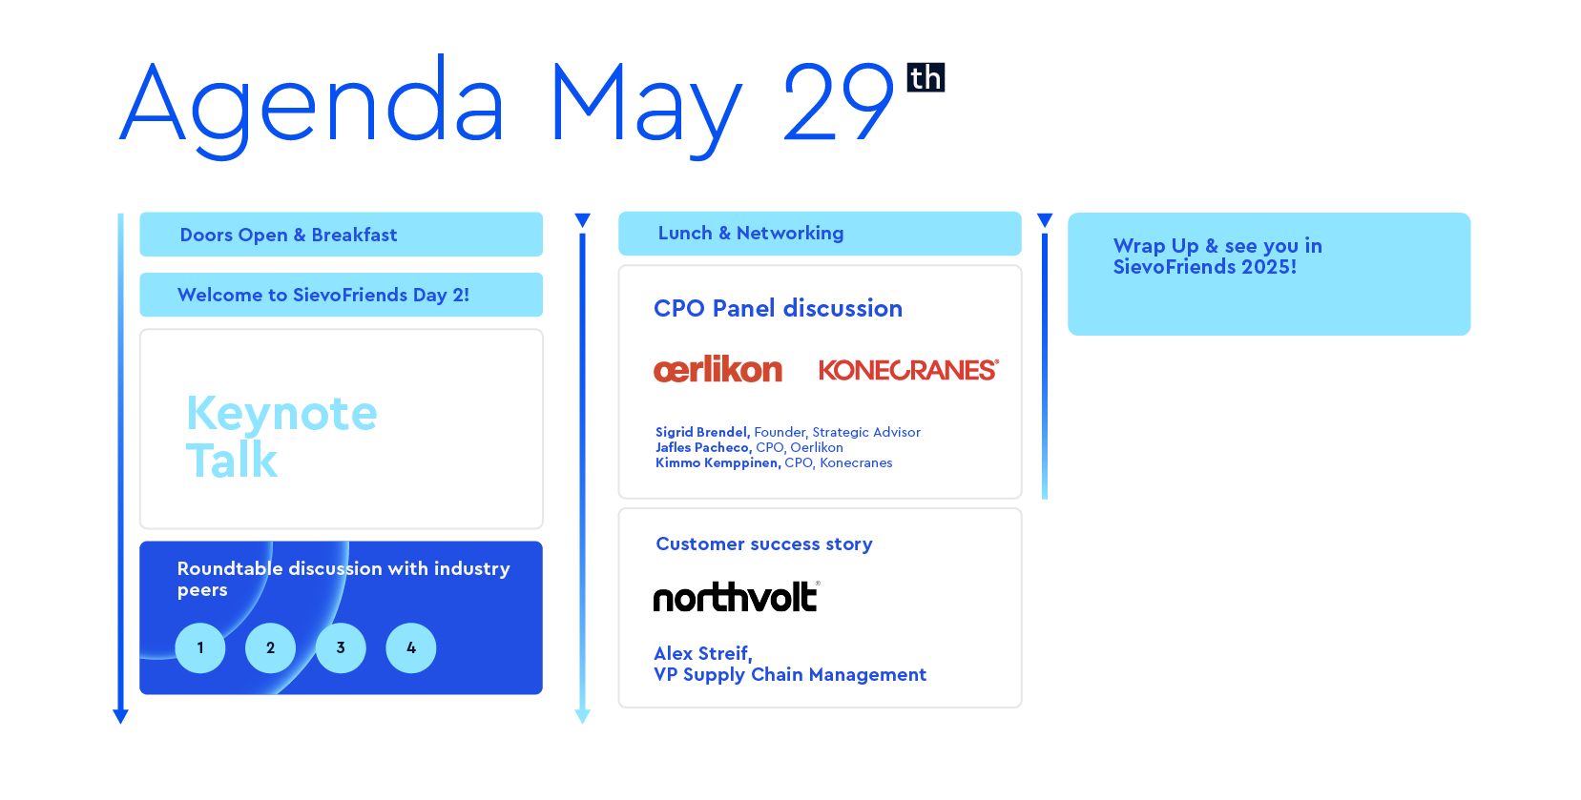
More info can be found on their website at SievoFriends Helsinki.

The approximate investment for my attendance is as follows:
Travel Costs | €XXX
Accommodation | €XXX
Meals (Breakfast, lunch and dinner for event days are provided by Sievo at the venue) | Complimentary
Conference Registration | Complimentary
Total Costs | €XXX

Thank you so much for your consideration.
Sincerely,
(Your Name)

